KONGARA SAI
192365025
LAB EXPERIMENTS_INTERNETPROGRAMMING_CSA4308
Exp-1
A local library needs a website to streamline operations and enhance user
experience. The site will include a catalog for searching and viewing books, user
accounts for borrowing and managing books, and an admin dashboard for
managing inventory and user data. Essential features include a search function,
book details page, user login system, and contact form, The system helps both
students and library managers to keep constant track of all the books available in
the library. It allows both the admin and the student to search for the desired book.
It becomes necessary for colleges to keep a continuous check on the books issued
and returned and even calculate fines.
Librarian Admin:
• Login
• Add Book
• Update/Delete Book
• Issue Book for student
• Return Book Status
• Make Fine
• Update material ( year, semester wise )
• View material
User
• Login
• Register
• Search Book
• My Borrow History Book
o Issue Date, Exp Date
• Check Fine
• Search material ( year, semester wise )
• Download material
• My profile

Code:
<!DOCTYPE html>
<html>
<head>
<title>Library Management System</title>
<style>
body{font-family:Arial;background:#f2f2f2;margin:0}
header{background:#2c3e50;color:white;padding:20px;text-align:center}
nav button{padding:10px;margin:5px;background:#3498db;color:white;border:0}
.container{background:white;margin:30px auto;padding:20px;max-width:800px}
input,select{padding:10px;margin:8px;width:90%}
button{padding:10px;background:#3498db;color:white;border:0}
.book{background:#eee;padding:15px;margin:10px}
</style>
</head>

<body>

<header>
<h1>📚 Library Management System</h1>
<button onclick="home()">Home</button>
<button onclick="books()">Books</button>
<button onclick="login()">Login</button>
<button onclick="admin()">Admin</button>
</header>

<div class="container" id="content">
<h2>Welcome to College Library</h2>
<p>Search, borrow and manage library books easily.</p>
</div>

<script>

function home(){
document.getElementById("content").innerHTML=
"<h2>Library Home</h2><p>Welcome Students and Librarians!</p>";
}

function books(){
document.getElementById("content").innerHTML=`
<h2>Search Books</h2>
<input id="search" placeholder="Search Book">
<div class="book"><h3>Java Programming</h3>
<p>Author: Herbert Schildt</p>
<p>Status: Available</p>
<button onclick="borrow()">Borrow</button></div>
<div class="book"><h3>Database Management</h3>
<p>Author: Silberschatz</p>
<p>Status: Available</p>
<button onclick="borrow()">Borrow</button></div>`;
}

function borrow(){
alert("Book Issued Successfully!");
}

function login(){
document.getElementById("content").innerHTML=`
<h2>User Login</h2>
<input placeholder="Email">
<input type="password" placeholder="Password">
<button onclick="alert('Login Successful')">Login</button>`;
}

function admin(){
document.getElementById("content").innerHTML=`
<h2>Librarian Admin</h2>
<input placeholder="Book Name">
<input placeholder="Author">
<input placeholder="Year">
<button onclick="alert('Book Added')">Add Book</button>
<h3>Manage Books</h3>
<button onclick="alert('Book Updated')">Update Book</button>
<button onclick="alert('Book Deleted')">Delete Book</button>
<h3>Issue / Return</h3>
<button onclick="alert('Book Issued')">Issue Book</button>
<button onclick="alert('Book Returned')">Return Book</button>
<h3>Fine</h3>
<input placeholder="Fine Amount">
<button onclick="alert('Fine Added')">Make Fine</button>`;
}

</script>

</body>
</html>
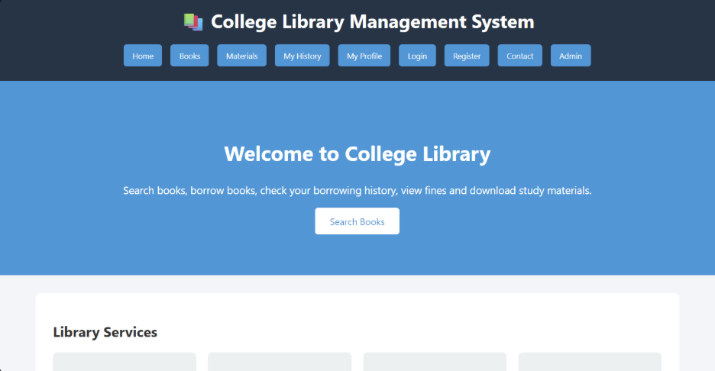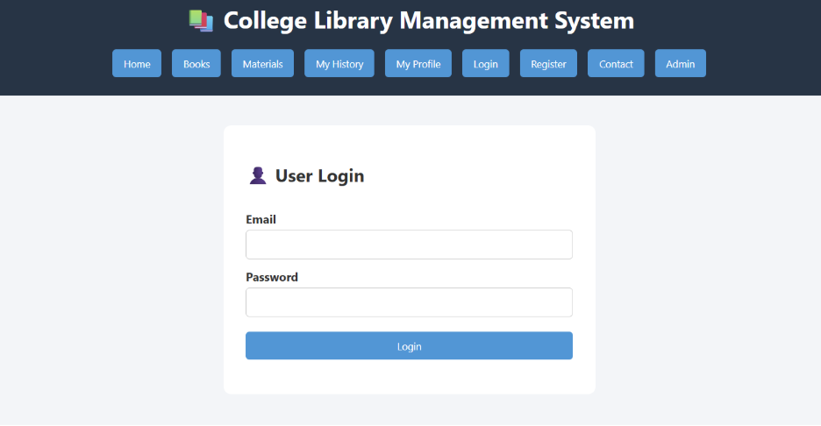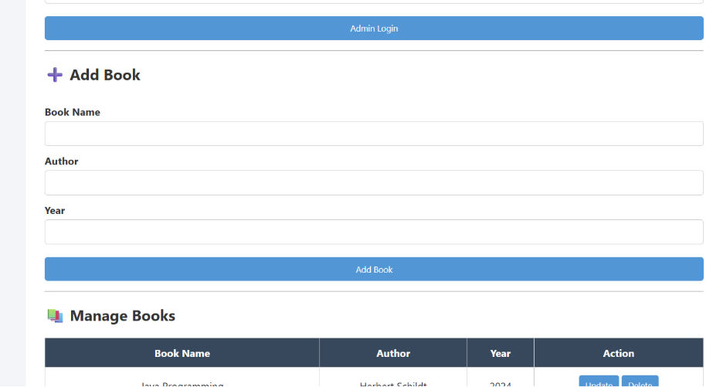

Exp-2
The online hotel room booking website allows users to search for hotels based on destination,
dates, and number of guests, offering detailed listings with room options, prices, amenities, and
reviews. Users can create accounts, log in, and manage their bookings through a user-friendly
dashboard. The booking process includes checking room availability, filling out a booking form,
and completing secure payments via an integrated payment gateway. Post-booking, users
receive confirmation emails and can leave reviews and ratings. Admins manage hotel listings,
room availability, and user accounts through a dedicated admin panel. The website is fully

INTERNET PROGRAMMING
LAB EXPRIMENTS
responsive, ensuring seamless access on all devices.
Functionalities:
Users.
1. Users can register at the hotel and then they can view or modify their profile.
2. Users can book a room on any specific date.
3. Users can view all their booking history at the hotel.
4. Users can change the booking at any time 3 days before the arrival date.
5. Users can cancel the booking at any time 3 days before the arrival date.
6. Users can check the room availability at the hotel before they book a room.
Administrator
7. Administrators can change the quantity and price of all four types of rooms.
8. Administrators can change any specific booking details.
9. Administrators can cancel any specific booking.
10. Administrators can modify the details of static pages including room information, about us
information, contact us information, customer service Q&A details, local travel and shipping
guide, and privacy policy after login.
11. It should also contain a basic room type introduction, contact information, customer service
Q&A, local travel and shipping guide, and a privacy policy
Code:
<!DOCTYPE html>
<html>
<head>
<title>Hotel Booking</title>
<style>
body{font-family:Arial;background:#eee;text-align:center}
header{background:#234;color:white;padding:20px}
button,input{padding:10px;margin:5px}
.room{background:white;margin:15px;padding:15px}
</style>
</head>
<body>
<header>
<h1>🏨 Hotel Room Booking</h1>
<button onclick="home()">Home</button>
<button onclick="rooms()">Rooms</button>
<button onclick="login()">Login</button>
<button onclick="booking()">My Bookings</button>
<button onclick="admin()">Admin</button>
</header>

<div id="app">
<h2>Welcome to Our Hotel</h2>
<p>Search and book your room easily.</p>
</div>

<script>
function home(){
app.innerHTML="<h2>Welcome to Our Hotel</h2><p>Comfortable rooms at best prices.</p>";
}
function rooms(){
app.innerHTML=`
<h2>Search Rooms</h2>
<input placeholder="Destination">
<input type="date"><input type="date">
<input placeholder="Guests">
<button onclick="alert('Room Available')">Check Availability</button>
<div class="room"><h3>Single Room</h3><p>$50 | WiFi | AC</p>
<button onclick="book()">Book Now</button></div>
<div class="room"><h3>Double Room</h3><p>$80 | WiFi | AC</p>
<button onclick="book()">Book Now</button></div>`;
}

function book(){
alert("Room booked successfully!");
}

function login(){
app.innerHTML=`
<h2>User Login</h2>
<input placeholder="Email">
<input type="password" placeholder="Password">
<button onclick="alert('Login Successful')">Login</button>
`;
}
function booking(){
app.innerHTML=`
<h2>My Booking</h2>
<p>Room: Double Room</p>
<p>Date: 10-08-2026</p>
<p>Status: Confirmed</p>
<button onclick="alert('Booking Modified')">Modify</button>
<button onclick="alert('Booking Cancelled')">Cancel</button>`;
}
function admin(){
app.innerHTML=`
<h2>Admin Panel</h2>
<input placeholder="Room Type">
<input placeholder="Quantity">
<input placeholder="Price">
<button onclick="alert('Room Updated')">Update Room</button>
<button onclick="alert('Booking Cancelled')">Cancel Booking</button>
<p>Admin can manage rooms, bookings and website pages.</p>`;
}
</script>
</body>
</html>
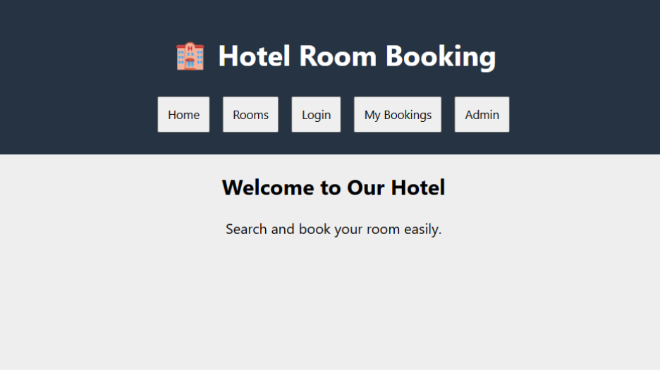
Exp-3
3. The online bus ticket booking system enables users to search for buses by route, date, and time,
and view available seats. Users can create an account, log in, and manage their bookings
through a personal dashboard. The booking process includes selecting seats, filling out
passenger details, and making secure payments via an integrated payment gateway. Admins
can manage bus schedules, seat availability, and user accounts through an admin panel. Users

receive booking confirmation emails and can view their booking history. The website is mobile-
responsive, ensuring easy access on all devices.

Admin
In this system, the admin can maintain all the Bus information and maintain Bus category,
comments etc.
In this system, the admin can maintain the registered users, manage news, and the admin cangenerate
reports and manage the whole system.
Login:
Login Module includes various utilities like User Authentication, Change Password and Forgot

INTERNET PROGRAMMING
LAB EXPRIMENTS

Password.
Registration:
This website provides some facilities users can be Registered in this website. user can use thisfacility
so user can make a registration
.
Book the Ticket:
In this module, the admin can add a new bus category using this module. Bus Category contains
like Volvo, Slipper coach, coach etc.
Update Bus Information:
In this module, the admin can add or Update Bus using this module. It contains information
about the Bus type, photo, description, Location of the tour, Available Seats in Bus etc.
Cancel the Booking Ticket:
In this Module, the User can cancel the booking Ticket.
Comments:
In this Module, Users can Post Comments on a particular Bus.
Report Generation:
This module is used to generate a report.
Code:
<!DOCTYPE html>
<html>
<head>
<title>Bus Ticket Booking</title>
<style>
body{font-family:Arial;background:#eee;text-align:center}
header{background:#234;color:white;padding:20px}
button,input,select{padding:10px;margin:5px}
.bus{background:white;margin:15px;padding:15px}
</style>
</head>
<body>

<header>
<h1>🚌 Bus Ticket Booking System</h1>
<button onclick="home()">Home</button>
<button onclick="search()">Search Bus</button>
<button onclick="login()">Login</button>
<button onclick="register()">Register</button>
<button onclick="booking()">My Booking</button>
<button onclick="admin()">Admin</button>
</header>

<div id="app">
<h2>Welcome to Bus Booking</h2>
<p>Search and book your bus ticket easily.</p>
</div>

<script>
function home(){
app.innerHTML="<h2>Welcome</h2><p>Book your bus tickets online.</p>";
}

function search(){
app.innerHTML=`
<h2>Search Bus</h2>
<input placeholder="From">
<input placeholder="To">
<input type="date">
<input type="time">
<button onclick="alert('Bus Found')">Search</button>
<div class="bus"><h3>Volvo Bus</h3>
<p>Chennai to Bangalore</p><p>Seats Available: 20</p>
<button onclick="book()">Book Ticket</button></div>`;
}

function book(){
alert("Ticket booked successfully!");
}

function login(){
app.innerHTML=`
<h2>Login</h2>
<input placeholder="Username">
<input type="password" placeholder="Password">
<button onclick="alert('Login Successful')">Login</button>
<p>Forgot Password? | Change Password</p>`;
}

function register(){
app.innerHTML=`
<h2>Registration</h2>
<input placeholder="Name"><input placeholder="Email">
<input placeholder="Password">
<button onclick="alert('Registered Successfully')">Register</button>`;
}

function booking(){
app.innerHTML=`
<h2>My Booking</h2><p>Bus: Volvo</p>
<p>Route: Chennai to Bangalore</p>
<button onclick="alert('Booking Cancelled')">Cancel Ticket</button>`;
}

function admin(){
app.innerHTML=`
<h2>Admin Panel</h2>
<input placeholder="Bus Type">
<input placeholder="Route">
<input placeholder="Available Seats">
<button onclick="alert('Bus Updated')">Update Bus</button>
<button onclick="alert('Report Generated')">Generate Report</button>
<p>Admin manages buses, users, comments and reports.</p>`;
}
</script>
</body>
</html>

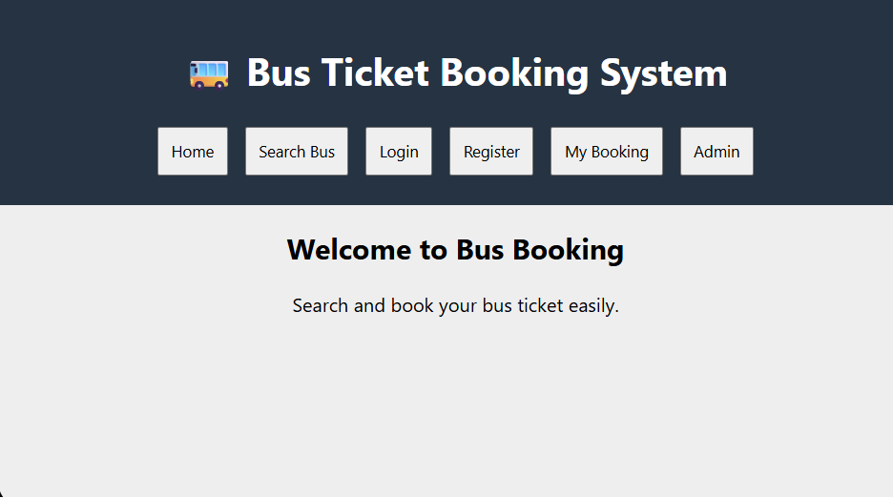
Exp-4
The online train reservation system allows users to search for trains by route, date, and time,
and view available seats and classes. Users can register, log in, and manage their reservations
through a personal dashboard. The booking process involves selecting seats, entering passenger
details, and making secure payments via an integrated payment gateway. Admins can manage
train schedules, seat availability, and user accounts through a comprehensive admin panel.
Users receive booking confirmation emails and can view their booking history and print tickets
from their dashboard. The website features real-time seat availability updates and is fully
responsive for seamless use on all devices.
The Reservation system should contain the following features:
1. If a passenger wants to reserve ticket(s), firstly, he/she has to log in to the Railway
system with valid credentials. Then, the passenger has to provide his/her details with
the date of the journey, names of the passengers and their details, origin station
details, destination station details, and the class type of the required ticket(s).

2. The Railway Reservation System will provide the available Train-list, and Seat-
availability, via-details.

3. To book a ticket passengers can pay through online/offline mode. After successful
payment of the ticket fare the System will generate the ticket and PNR no. will be
given to the passenger. The System also keeps the payment details and sends them
to the system Admin.
4. The Passenger can check PNR status (confirmed, RAC, waiting list) by entering the
PNR no. into the Reservation system.
5. The Reservation system should store all train details, fare details (by zone, class,
and date wise), PNR no, date of trains, etc. This maintenance should be controlled
by the Admin.
6. The System also has refund rules which have a date of reservation, ticket fare, and
refundable percentage. The passenger can simply cancel the ticket(s) by entering
the PNR no and a cancel ticket request. After cancellation, the admin will pass the
refundable amount to the System and the System will give the refundable amount
to the passenger.
Code:
<!DOCTYPE html>
<html>
<head>
<title>Train Reservation System</title>
<style>
body{font-family:Arial;background:#eee;text-align:center}
header{background:#234;color:white;padding:20px}
button,input,select{padding:10px;margin:5px}
.train{background:white;margin:15px;padding:15px}
</style>
</head>
<body>

<header>
<h1>🚆 Train Reservation System</h1>
<button onclick="home()">Home</button>
<button onclick="search()">Search Train</button>
<button onclick="login()">Login</button>
<button onclick="register()">Register</button>
<button onclick="pnr()">Check PNR</button>
<button onclick="admin()">Admin</button>
</header>

<div id="app">
<h2>Welcome to Railway Reservation</h2>
<p>Search trains and reserve your tickets online.</p>
</div>

<script>
function home(){
app.innerHTML="<h2>Welcome</h2><p>Book your train tickets easily.</p>";
}

function search(){
app.innerHTML=`
<h2>Search Train</h2>
<input placeholder="Origin Station">
<input placeholder="Destination Station">
<input type="date">
<select><option>AC</option><option>Sleeper</option><option>General</option></select>
<button onclick="alert('Train Found')">Search</button>
<div class="train"><h3>Express Train</h3>
<p>Available Seats: 25</p><p>Fare: $50</p>
<button onclick="book()">Book Ticket</button></div>`;
}

function book(){
alert("Ticket Booked! PNR: TR123456");
}

function login(){
app.innerHTML=`
<h2>Passenger Login</h2>
<input placeholder="Username">
<input type="password" placeholder="Password">
<button onclick="alert('Login Successful')">Login</button>`;
}

function register(){
app.innerHTML=`
<h2>Passenger Registration</h2>
<input placeholder="Name"><input placeholder="Email">
<input placeholder="Password">
<button onclick="alert('Registration Successful')">Register</button>`;
}

function pnr(){
app.innerHTML=`
<h2>Check PNR Status</h2>
<input placeholder="Enter PNR Number">
<button onclick="alert('Status: Confirmed')">Check Status</button>
<p>PNR Status: Confirmed / RAC / Waiting List</p>`;
}

function admin(){
app.innerHTML=`
<h2>Admin Panel</h2>
<input placeholder="Train Name">
<input placeholder="Train Number">
<input placeholder="Available Seats">
<button onclick="alert('Train Details Updated')">Update Train</button>
<button onclick="alert('Refund Processed')">Process Refund</button>
<p>Admin manages trains, fares, users, PNR and payments.</p>`;
}
</script>
</body>
</html>
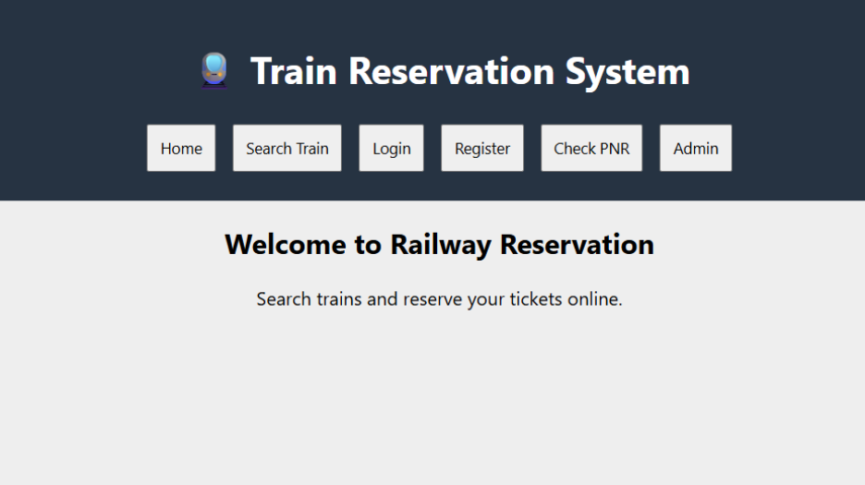
Exp-5
The online flight reservation system enables users to search for flights by
destination, date, and class, displaying available options with real-time seat availability.
Users can register, log in, and manage their reservations via a personal dashboard. The
booking process includes selecting flights, choosing seats, entering passenger details, and
making secure payments through an integrated payment gateway. Admins can manage
flight schedules, seat inventory, and user accounts using an advanced admin panel. Users
receive booking confirmation emails with e-tickets and can view their booking history and

INTERNET PROGRAMMING
LAB EXPRIMENTS

travel itineraries. The website is fully responsive, ensuring an optimal experience on all
devices.The airline reservation system is a web-based system that helps in consolidating
flight data - flight schedules, seat availability, flight fares and reservations from all
airlines with the help of global distribution systems and provides real-time inventory and
rates for customers and travel agents to book flight tickets online.
• Administrator User Login Page
• Forgot Password Page
• Search Flight Page
• Book Ticket Page
• Ticket Payment Page
• My Ticket Page
• Cancel Ticket Page
• Customer Feedback
• Admin Report
• Search Flight Page
• View Booking Status Page
• Print Ticket Page
Code:
<!DOCTYPE html>
<html>
<head>
<title>Flight Reservation System</title>
<style>
body{font-family:Arial;background:#eee;text-align:center}
header{background:#234;color:white;padding:20px}
button,input,select{padding:10px;margin:5px}
.flight{background:white;margin:15px;padding:15px}
</style>
</head>
<body>

<header>
<h1>✈️ Flight Reservation System</h1>
<button onclick="home()">Home</button>
<button onclick="search()">Search Flight</button>
<button onclick="login()">Login</button>
<button onclick="bookings()">My Ticket</button>
<button onclick="status()">Booking Status</button>
<button onclick="admin()">Admin</button>
</header>

<div id="app">
<h2>Welcome to Flight Reservation</h2>
<p>Search and book your flight tickets online.</p>
</div>

<script>
function home(){
app.innerHTML="<h2>Welcome</h2><p>Book your flight easily and securely.</p>";
}

function search(){
app.innerHTML=`
<h2>Search Flight</h2>
<input placeholder="Destination">
<input type="date">
<select><option>Economy</option><option>Business</option></select>
<button onclick="alert('Flight Found')">Search</button>
<div class="flight"><h3>Air India</h3>
<p>Chennai to Delhi</p><p>Seats Available: 20</p>
<p>Fare: $150</p>
<button onclick="book()">Book Ticket</button></div>`;
}

function book(){
alert("Ticket Booked Successfully!");
}

function login(){
app.innerHTML=`
<h2>Customer Login</h2>
<input placeholder="Email">
<input type="password" placeholder="Password">
<button onclick="alert('Login Successful')">Login</button>
<p>Forgot Password?</p>`;
}

function bookings(){
app.innerHTML=`
<h2>My Ticket</h2>
<p>Flight: Air India</p><p>Status: Confirmed</p>
<button onclick="alert('Ticket Printed')">Print Ticket</button>
<button onclick="alert('Ticket Cancelled')">Cancel Ticket</button>`;
}

function status(){
app.innerHTML=`
<h2>Booking Status</h2>
<input placeholder="Booking ID">
<button onclick="alert('Status: Confirmed')">Check Status</button>`;
}

function admin(){
app.innerHTML=`
<h2>Admin Panel</h2>
<input placeholder="Flight Name">
<input placeholder="Available Seats">
<input placeholder="Flight Fare">
<button onclick="alert('Flight Updated')">Update Flight</button>
<button onclick="alert('Report Generated')">Admin Report</button>
<p>Admin manages flights, seats, users and bookings.</p>`;
}
</script>
</body>
</html>

